Couple sues after town bans front-yard gardens Associated Press June 11, 2016 at 6:40 am 5Lead Stories, News
MIAMI (AP) — For 17 years, a South Florida couple grew vegetables in a front-yard garden until a new town ordinance was passed limiting such gardens to backyards. Now, the couple is asking a judge to uproot the ban they claim violates their constitutional rights.
Tom Carroll and Hermine Ricketts say they dug up the garden in front of their Miami Shores home in August 2013 when town officials threatened to fine them $50 a day if they didn’t. The threatened fine came a few months after the Miami Shores Village Council adopted a new zoning plan for the town of about 10,500 north of Miami. The couple sued, and at a hearing Wednesday their attorney said the ban violates the Florida Constitution in several ways, including improper limits on their private property rights and violation of the equal protection clause by singling out vegetables over other plants. “We’re not saying you can do anything you want on your property,” attorney Ari Bargil told Miami-Dade Circuit Judge Monica Gordo. “We are simply saying you can grow vegetables on your property and that is protected by the Constitution.” Richard Sarafan, attorney for Miami Shores, said the new zoning rule was not irrational and treated all homeowners the same: their front yards should be covered with grass, sod or a “living ground cover” not further defined. It’s no problem, he said, to have a vegetable garden in the backyard. “There certainly is not fundamental right to grow vegetables in your front yard,” Sarafan said. “Aesthetics and uniformity are legitimate government purposes. Not every property can lawfully be used for every purpose.” Carroll, who attended the hearing, said the couple sought to grow produce using organic practices, such as no use of pesticides. He said he had never gotten a complaint from a neighbor in all the years he tended the garden, which grew some 75 varieties of vegetables. “It’s important that we have the right to do something on our own property,” Carroll said. “We’re just trying to grow vegetables.” The couple is being represented by lawyers from the Arlington, Virginia-based Institute for Justice, which describes itself as a Libertarian nonprofit organization that focuses on issues such as private property rights, school choice and free speech. Gordo did not immediately rule. Both sides said the judge could decide the matter without a trial, but either way the case is likely to be appealed, attorneys said. Copyright 2016 The Associated Press. All rights reserved. This material may not be published, broadcast, rewritten or redistributed.

—-This content is published through a licensing agreement with Acquire Media using its NewsEdge technology.
- baitfish June 11, 2016 at 9:23 amThe city ordinance “violates the equal protection clause by singling out vegetables over other plants.” Wow, who knew vegetables would become a protected class under the law.
That bit of ridiculousness out of the way, the growing of food on one’s own land should NEVER be subject to the whims of a “city council.”
- Jeff Miller June 11, 2016 at 10:56 am“Aesthetics and uniformity are legitimate government purposes.”
I can’t seem to find that in the enumerated powers. Maybe it’s a local ordinance, but only a majority of Progressive liberals would pass something like that.
And since when are tomatoes, green beans, and carrots not “living ground cover?”
- disqus_DW3qxKdlwn June 11, 2016 at 11:04 amMassachusetts, a liberal state, has a Right To Farm Law which allows land to be used for growing crops regardless of what the local laws including zoning laws are. If Florida had a similar law, that couple would be able to get relief from Florida insofar as that ordinance be deemed unconstitutional or unenforceable.
- Rgr Lms June 11, 2016 at 11:29 am….. I am ALWAYS amazed at the People who become “Rulers” in these Associations. All of the sudden they become Dictator-Democrats, telling Every person AND older person what to do and when to do it. They will FINE them Rather than visit them to see if they need help And Can Get Some Government help for them, Of Which they are All partakers in some way. What A Bunch of Hypocrites. We have run into it many times with friends over: Weeds in the yard ( Dandelions in the Spring ), unpainted mail boxes, Leaning fences After A Storm, visitors cars parked in the drive for Too Many Days In a Row, Leaves not racked between storms, too many Palm Frawns hanging on a tree,,,,, etc, etc, etc. Some of these people have lived in their neighborhood longer than these people have had friends!!! We have entered a ControlFreek, Power hungry, a-moral, inconsiderate period of time. >>> I have Deer ripping up my area and they won’t let me Kill them. We used to see them a couple times a year. Now we see them ALL Day long. They come Watch us: cut grass, Split wood, wash the car…. you name it. They are bored. I want them to Come to see a Butchering and a “Roast”!!! We have 10 to 15 crossing the road now and then.. In The City of 40,000 people, Two Freeways, Two State Roads and a lot of greenery, with a park system running through the city. We could feed all the needy and homeless in the city off of these critters.
- Benjamine Ghad June 11, 2016 at 12:40 pmTwo amendments are violated:4th: The right of the people to be secure in their persons, houses, papers, and effects, against unreasonable searches and seizures, shall not be violated, and no Warrants shall issue, but upon probable cause, supported by Oath or affirmation, and particularly describing the place to be searched, and the persons or things to be seized. (and property of the owners, even if only vegetables, falls under this amendment)7th: In Suits at common law, where the value in controversy shall exceed twenty dollars, the right of trial by jury shall be preserved, and no fact tried by a jury, shall be otherwise re-examined in any Court of the United States, than according to the rules of the common law. (And clearly, at $50 a day, that EXCEEDS the limit set by the 7th amendment)

Billy Graham: Why Does God Warn Against Horoscopes?
BY KATHERINE WEBER , CHRISTIAN POST REPORTER June 8, 2016|4:11 pm
Evangelist Billy Graham speaks at the Billy Graham Library in Charlotte, North Carolina, May 31, 2007.

Christians should look to God instead of horoscopes for guidance, the Rev. Billy Graham advises for those who are lured by things that claim to predict the future. 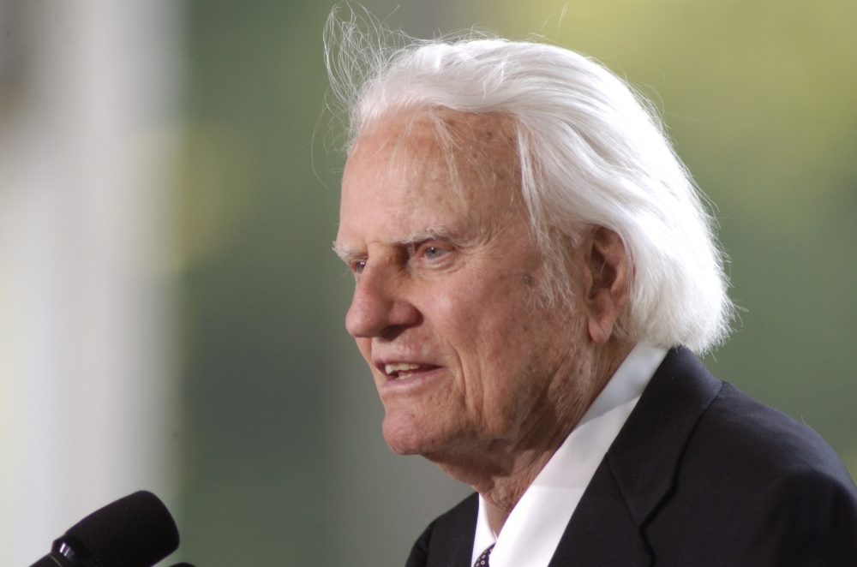
Graham, founder of the Billy Graham Evangelistic Association, said in a column for the Kansas City Star on Wednesday that although God created the stars and the universe, believers in Christ should not use these cosmic entities for guidance.
This includes referencing horoscopes and other methods, such as sorcery, omens or magic, as a source of guidance other than God, Graham continues.
"God did make the stars (as well as everything else in the universe), but He intended them to be a witness to His power and glory, not as a means to guide us or foretell the future," the evangelical leader writes.
The 97-year-old Baptist minister points specifically to Deuteronomy 18:9-13, in which God forbids His people from looking to such things for direction.
"Let no one be found among you who sacrifices their son or daughter in the fire, who practices divination or sorcery, interprets omens, engages in witchcraft, or casts spells, or who is a medium or spiritist or who consults the dead. Anyone who does these things is detestable to the Lord; because of these same detestable practices the Lord your God will drive out those nations before you," the verses read, in part.
One of the reasons God forbids us from using such alternatives as guidance is because they are dangerous, deceptive and unreliable. Graham points to the story of King Saul in 1 Samuel 28-31, who seeks to consult with a dead person about his future and ultimately commits suicide.
Instead, Graham concludes his message by encouraging Christians to look only to God for guidance.
"God loves us, and we know this because He sent His only Son, Jesus Christ, into the world to give His life for our salvation. Even when the future is unclear, He can be trusted to guide us," the evangelical leader says.
Graham has decried the use of astrology before, saying in a blog post for the "My Answers" section of the BGEA website that God alone should be our guiding light.
"[God] alone is our guide, and we are to look to Him alone for the wisdom we need. Nothing else is to take His rightful place," the evangelical leader explains.
"The Bible teaches that we should have nothing to do with occult practices, including [horoscopes and astrology]. I realize you may not think of them this way — but they are, because they all involve mystical attempts to foretell the future (which the Bible rejects)," Graham continues, referencing Isaiah 47:13-14 in which Isaiah mocks those who choose astrology over God.
"Let your astrologers come forward, those stargazers who make predictions month by month, let them save you from what is coming upon you," the verses read.

The preacher encourages Christians to build "[their] life on the truth of His Word, the Bible, because it alone is 'a lamp to my feet and a light for my path.'
Read more at http://www.christianpost.com/news/billy-graham-what-the-bible-says-about-horoscopes-fortune-tellers-164972/#TF6ESkzLXr32IT39.99

